Task on Linux Commands
Task 1: Create user Techie and provide sudo access
First, I created the user using sudo useradd Techie1 then, I set a password for the user sudo passwd Techie1 and Verify that the user has been successfully added to the required group.
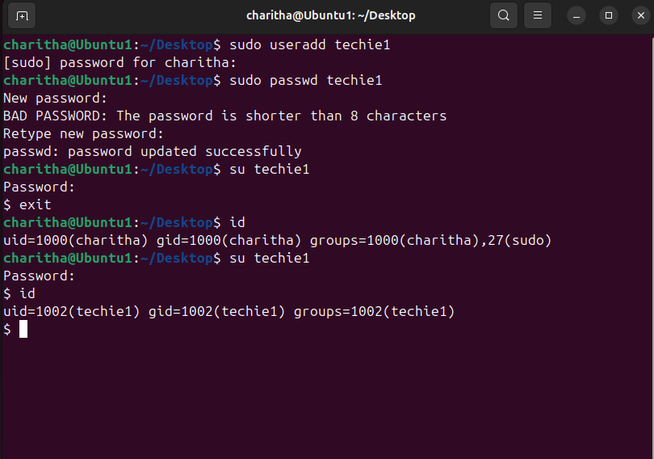
Task 2: Navigate to the Home Directory
I navigated to the home directory using the cd ~ command. This command takes me to the default home location of the user.
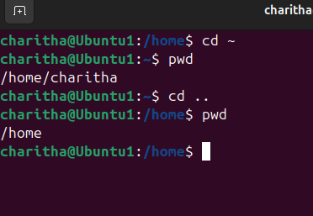
3)Create a new directory.
I created a new directory using mkdir umesh. This helped me to organize files.
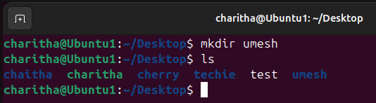
4)List the contents of a directory.
I listed files using ll. This showed all files and folders.
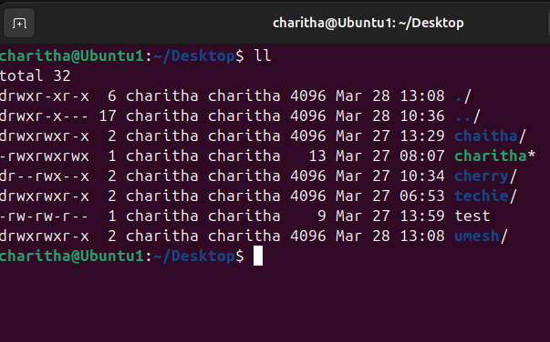

5)Change the current directory.
I changed directory using cd This moved to home
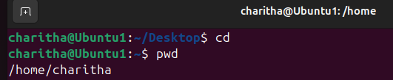
6)Create a new empty file.
I created a file using touch . This created an empty file.
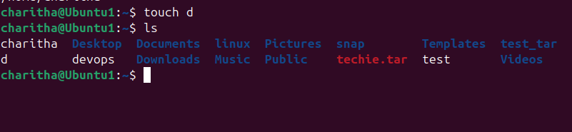
7)View the contents of a file.
The contents of the file were viewed using the cat command.
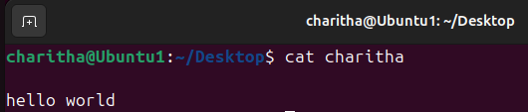
8)Copy a file to another location.
A file was copied to another location using the cp command.
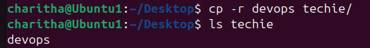
9)Move a file to another location.
A file was moved to a different location using the mv command.
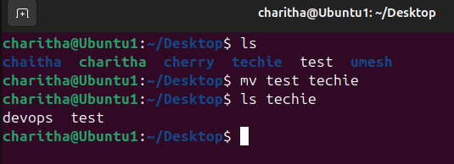
10)Rename a file.
A file was renamed using the mv command.
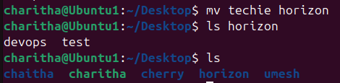
11)Delete a file.
A file was deleted using the rm -rf command.
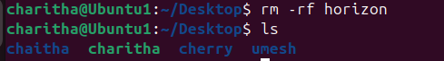
12)Grant or revoke permissions on a file or directory.
File permissions were changed using the chmod command.
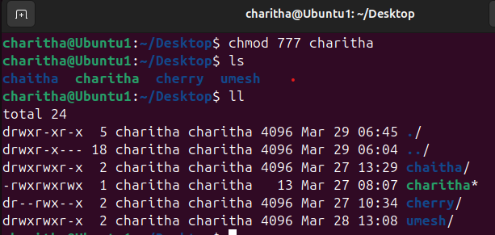
13)View the current date and time.
The current date were displayed using the date command.

14)Check the system uptime.
System uptime was checked using the uptime command.
15)View the running processes.
Running processes were viewed using the ps aux and top commands.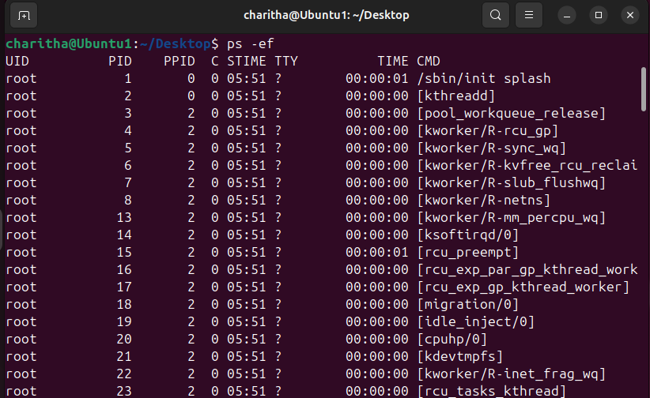
16)Kill a running process.
A running process was terminated using the kill -9 command.
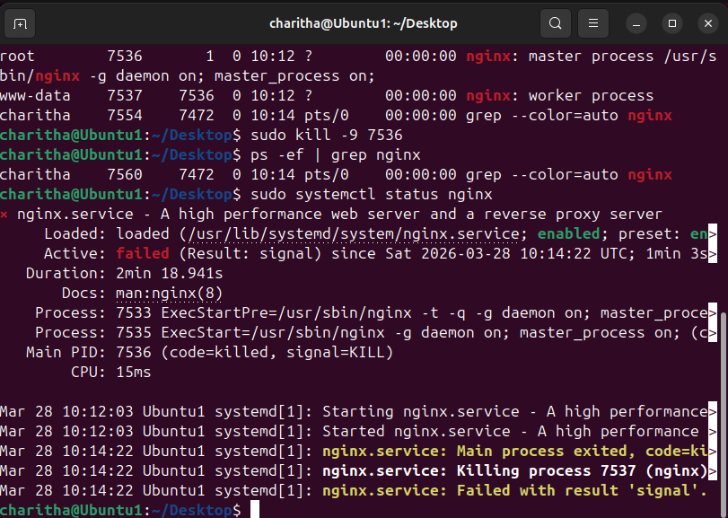
17)Install a package using the package manager (e.g., apt or yum).
A package was installed using the apt install command.
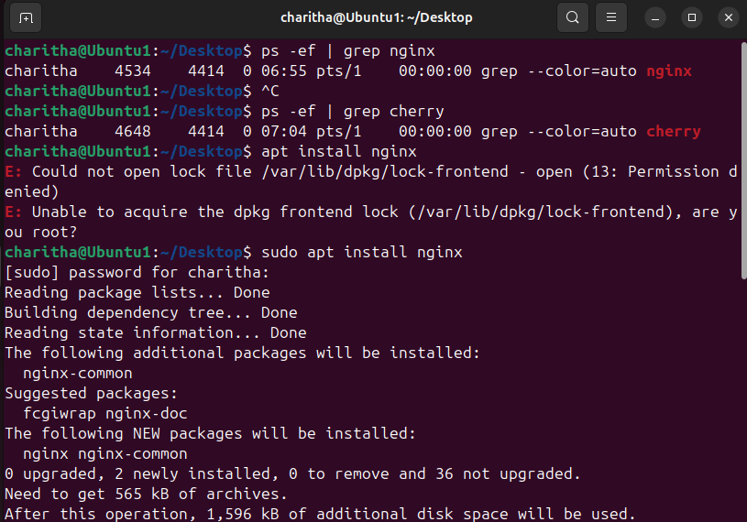
18)Update the system packages
System packages were updated using apt update and apt upgrade.
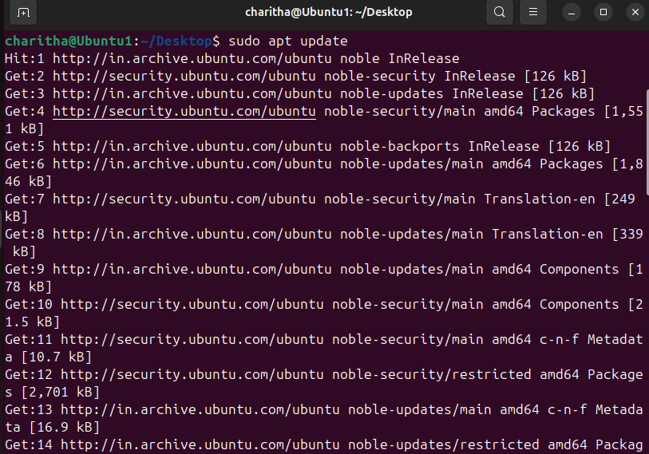
19)Create a symbolic link.
A symbolic link was created using the ln -s command.
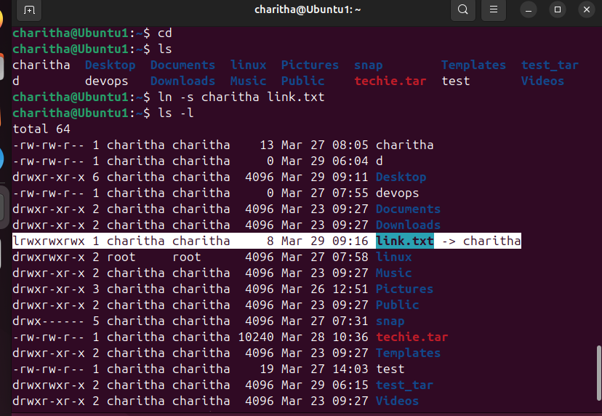
20)Search for files using the find command.
Files were searched using the find command.
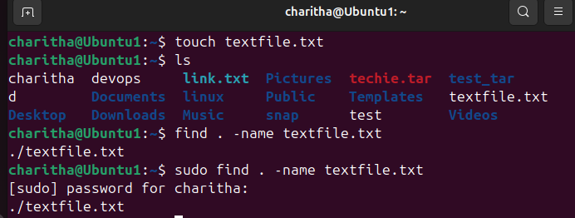
21)Compress and decompress files using tar.
Files were compressed and extracted using the tar command.
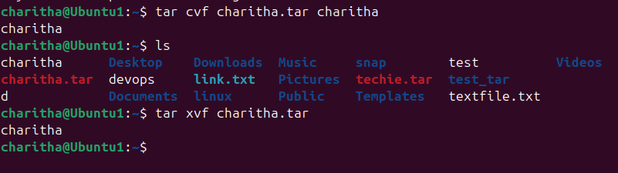
22)Monitor system resources with top or htop.
System resources were monitored using the top or htop command.
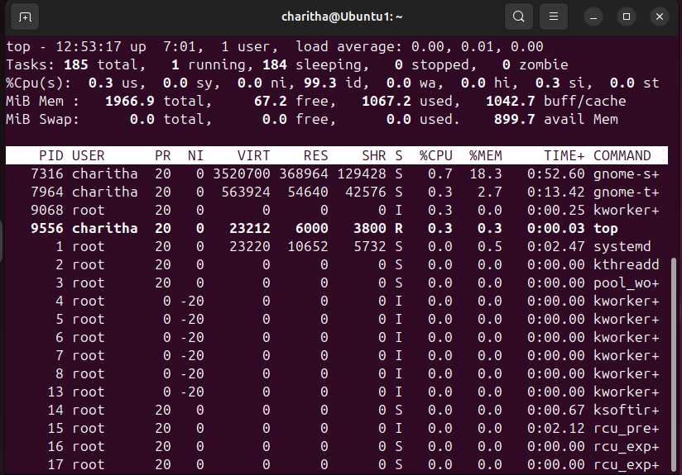
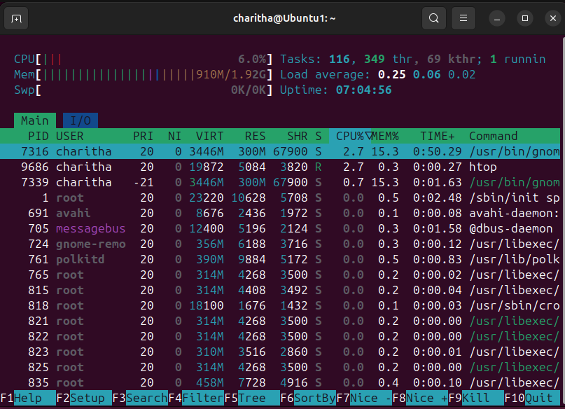

23)Create and manage user groups.
User groups were created and managed using groupadd, usermod, and gpasswd.
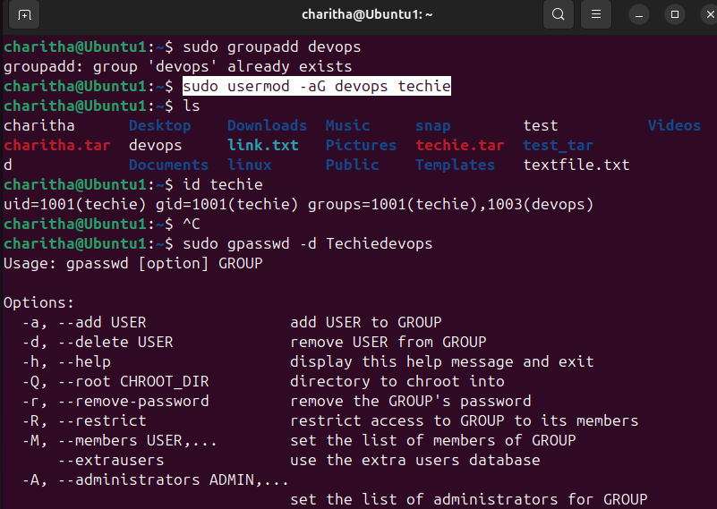

24)Set up SSH password less authentication.
SSH password-less authentication was configured using ssh-keygen and ssh-copy-id.
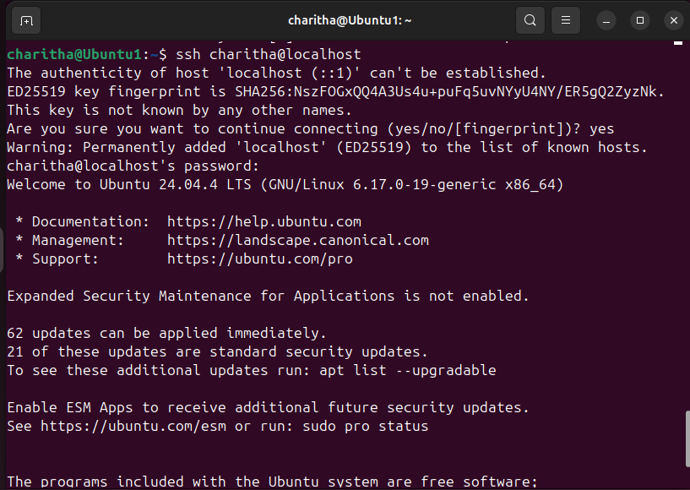
25)Monitor log files using tail or grep.
Log files were monitored using tail and filtered using grep.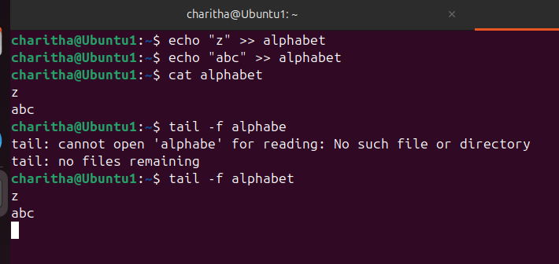
26)Set up a web server (e.g., Apache or Nginx).
A web server was set up using Apache and managed using systemctl.
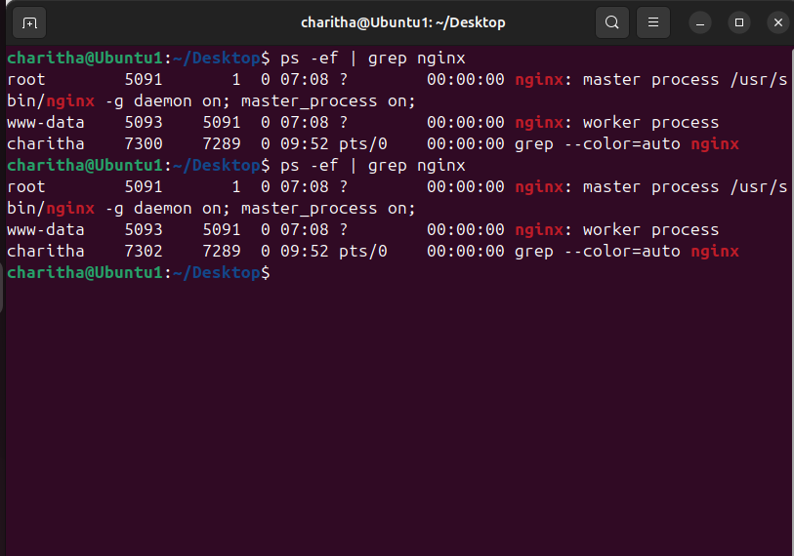
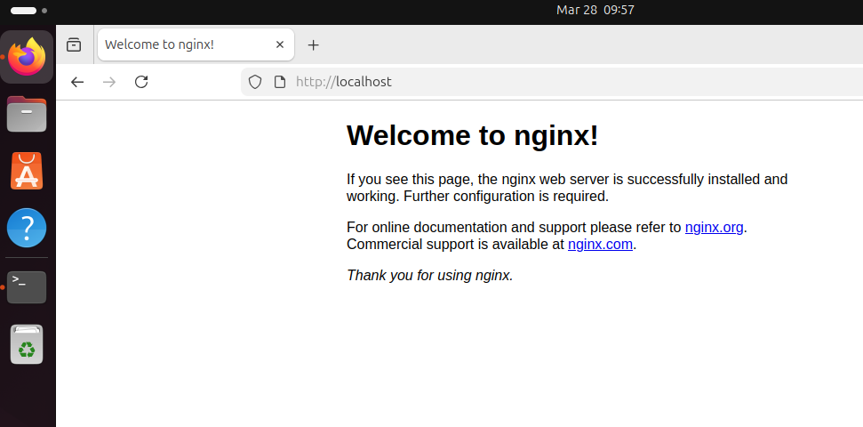
27)Configure and secure a MySQL Database.
A MySQL database was installed, secured, and configured with users and privileges.
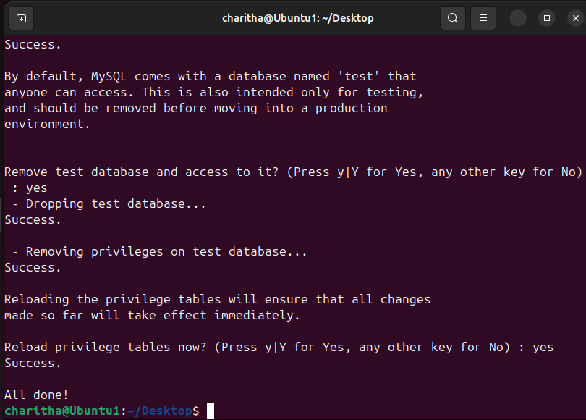
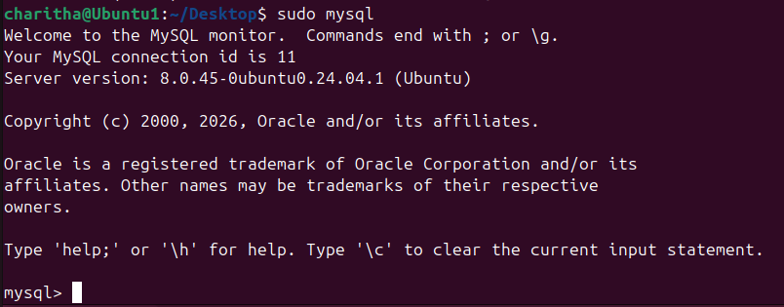
28)Set up a Application Server (e.g.,Apache Tomcat)
An application server was set up using Apache after installing Java.
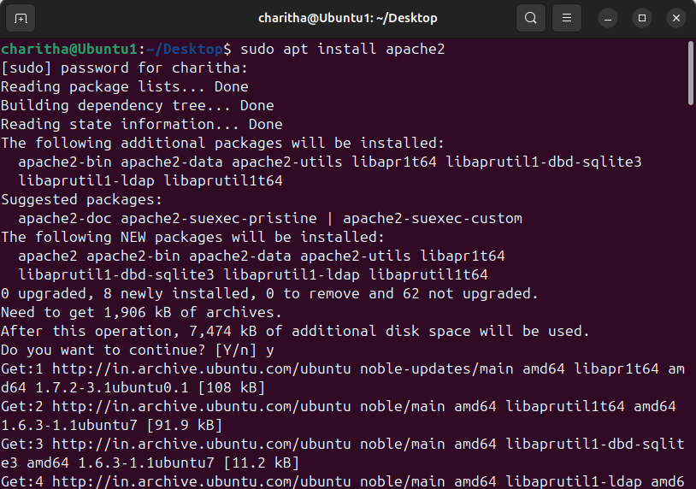
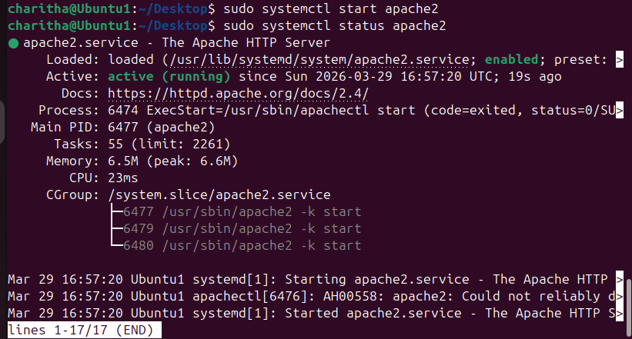
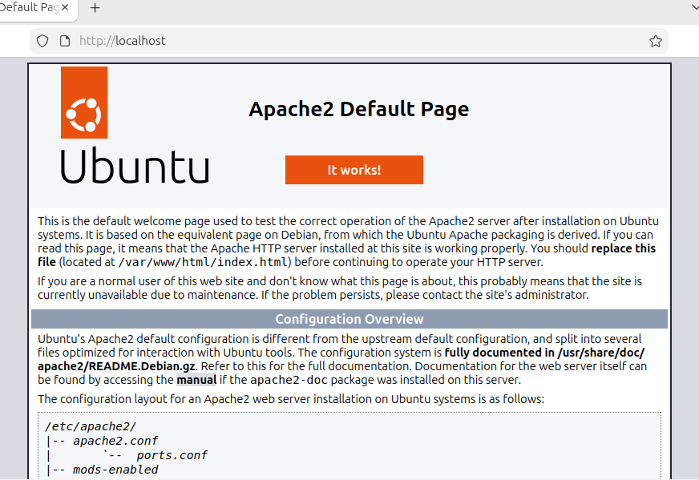
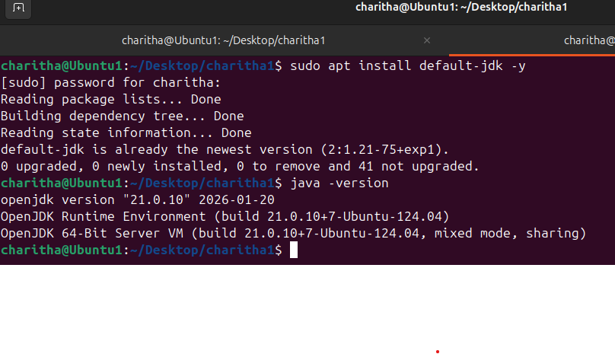29)create a service file for Apache Tomcat.(Should execute by using systemtctl command)
completed the file and started using systemctl start tomcat
command
Used this configuration service file to make work the systemctl start
tomcat
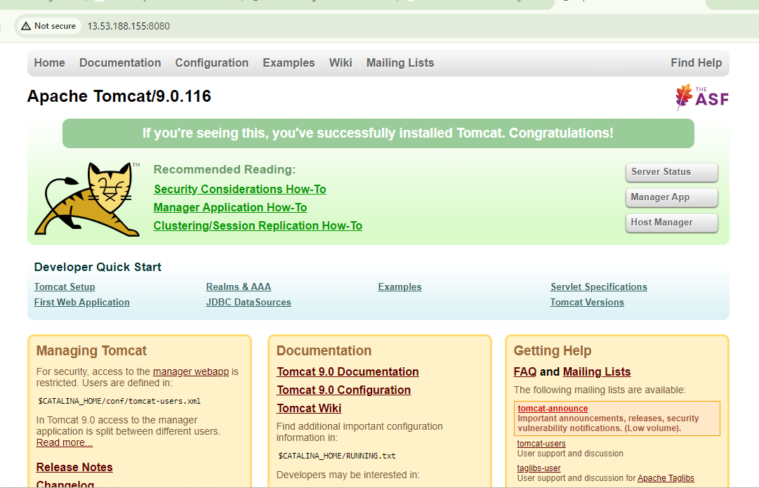
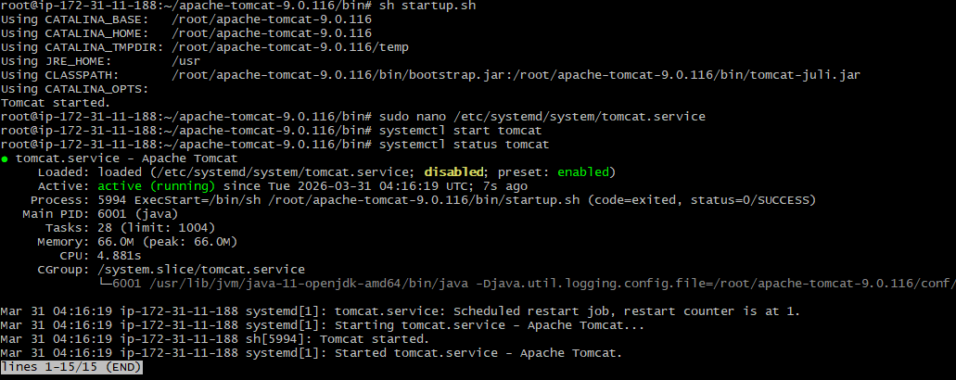
30)Print specific columns from a delimited file
Specific columns from a file were printed using the awk command..
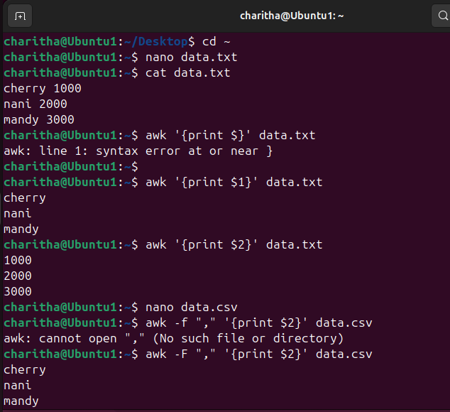
31)Filter and print lines based on a specific pattern or condition.
Lines were filtered based on a pattern using the grep command.
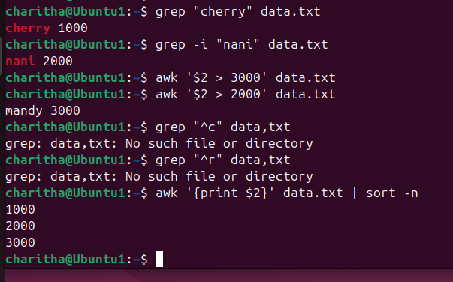
32)Calculate and print the average, sum, or other statistics of a column.
Column values like sum and average were calculated using awk.
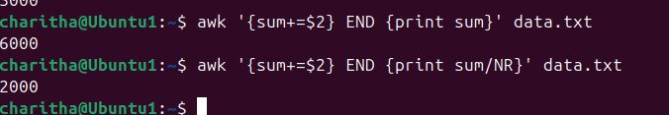33)Perform string manipulation, such as extracting substrings or changing case.
String operations like extracting fields were performed using awk and cut.
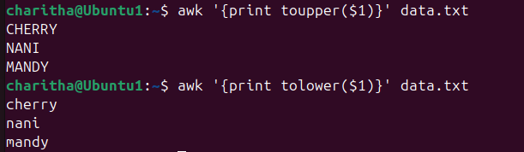
34)Count the occurrences of a specific pattern in a file.
Pattern occurrences were counted using grep -c.
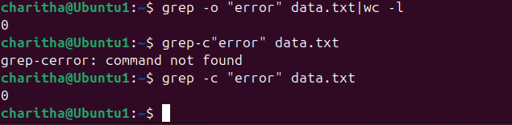
35)Sort lines based on a specific field or column.
Lines were sorted using the sort command.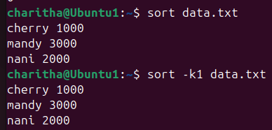
36)Merge multiple files based on a common field or column.
Multiple files were merged using the paste command.
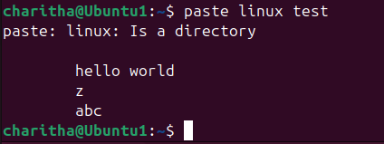
37)Substitute text in a file using search and replace.
Text was replaced in a file using the sed command.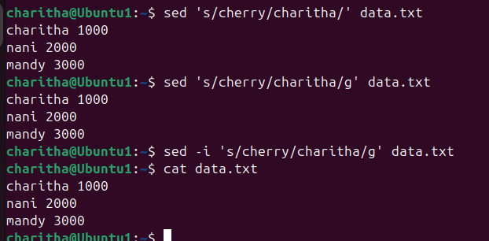
38)Delete specific lines based on a pattern or line number.
Specific lines were deleted using the sed command.
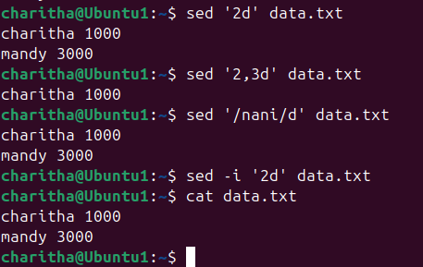
39)Append or insert text before or after a specific pattern or line.
Text was inserted before or after lines using the sed command.
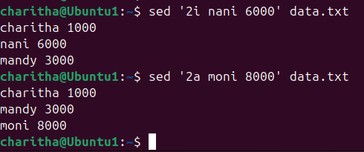
40)Print only specific lines from a file.
Specific lines were printed using the sed command.
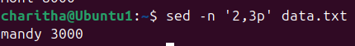
41) Copy file from linux to windows machine
We can use scp-I command for that
scp -i "royal.pem" ubuntu@13.53.188.155:/home/ubuntu/data /c/users/chari/downloads
42) 5 use cases for AWK and 5 use cases for sed
1.Insert text
Add text before a line
Sed’2i’data.txt
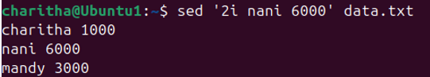
2.Print specific lines
Display selected lines
Sed -n’2p’data.txt

3.perforn calculations
Calculate sum,average,etc.
Awk’{sum+=$2}END {print sum}’data.txt
4.change text case uppercase and lowercase
Converting to get uppercase awk ‘{print toupper($1)}’ data.txt
Converting to get lowercase awk ‘{print tolower($1)}’ data.txt

5.perform calculations
Calculate sum/average,etc.
Awk’{sum+=$2}END {print sum}’data.txt
